DAY 5 – TEST PLANNING & TRACEABILITY
Test Planning: Test Plan concept, Test Plan vs Execution, sprint planning, release planning
Regression Strategy: Regression suites, reusable test packs, smart test selection
Traceability: Requirement → Test → Execution → Defect, coverage matrix, gap identification
Compliance View: Audit readiness, reporting expectations, stakeholder visibility

Test Planning: Test Plan concept, Test Plan vs Execution, sprint planning, release planning ::
Test planning is a strategic activity that defines how testing will be conducted to meet project objectives. It ensures that testing is aligned with release goals, timelines, and risk levels. In Agile and enterprise projects, effective test planning helps teams deliver high-quality software within tight schedules.
Test plan concept :
A Test Plan in Xray is used to organize and track testing activities for a specific release, version, or milestone.
Key Objectives of a Test Plan:
- Define scope of testing
- Identify tests to be executed
- Track execution progress
- Monitor defects and risks
Test Plans act as a central hub connecting tests, executions, and requirements.
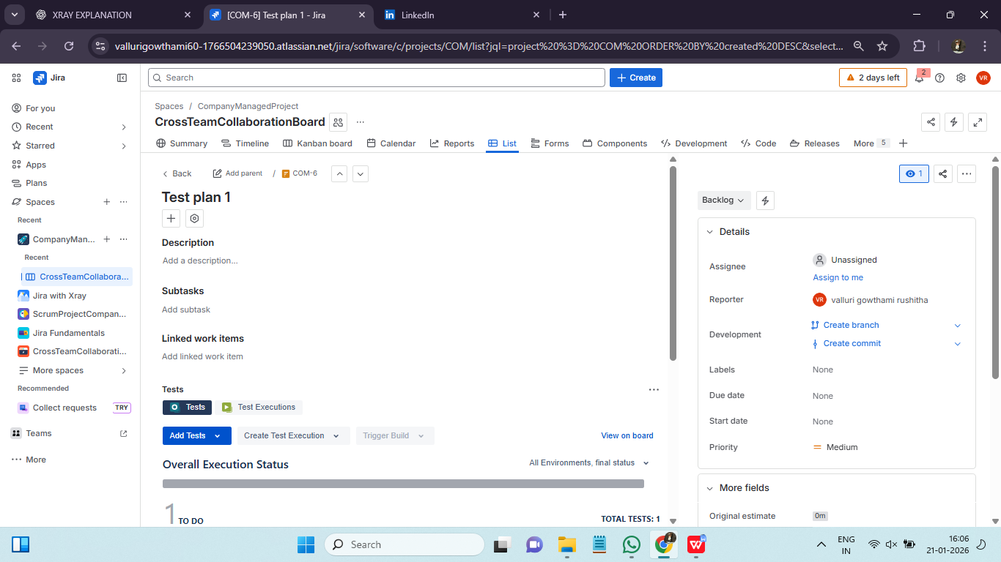
Test Plan vs Test Execution :
Although related, Test Plan and Test Execution serve different purposes.
Test Plan:
- High-level planning artifact
- Represents testing scope for a release
- Links multiple Test Executions
Test Execution:
- Represents actual execution of tests
- Records results and evidence
- Can exist independently or under a Test Plan
Understanding this distinction helps teams structure testing activities effectively.
Sprint-Level Test Planning :
In Agile projects, test planning happens at the sprint level.
Sprint Test Planning Activities:
- Review user stories
- Identify test scenarios
- Link tests to stories
- Define acceptance criteria
Xray allows teams to link tests directly to sprint stories, ensuring alignment with Agile workflows.
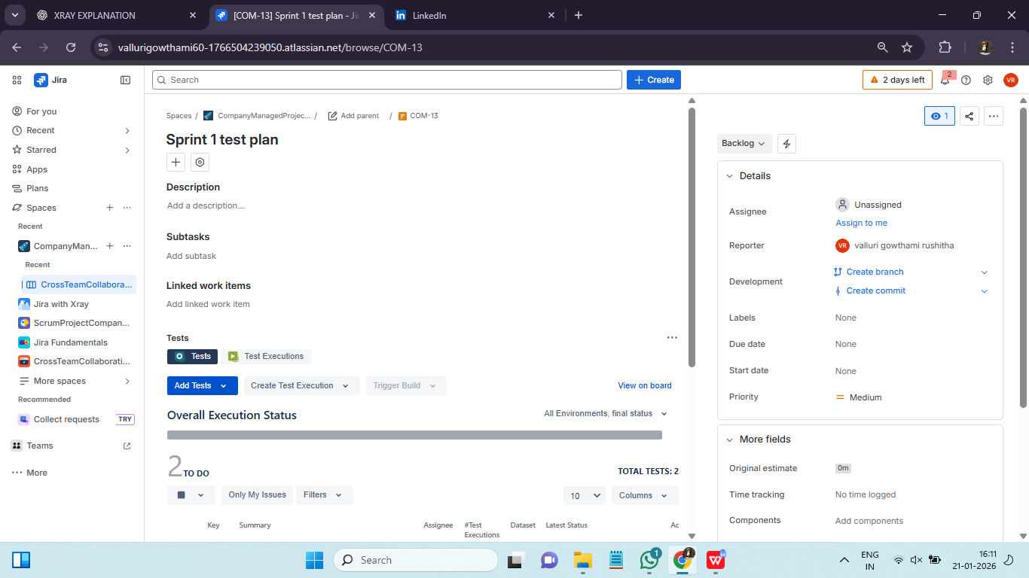
Release-Level Test Planning :
Release-level planning focuses on validating the application before production deployment.
Release Planning Includes:
- Regression testing
- Integration testing
- User acceptance testing
Using Test Plans, teams can monitor readiness and make informed go/no-go decisions.

Regression Strategy: Regression suites, reusable test packs, smart test selection ::
Regression testing ensures that existing functionality remains unaffected by new changes.
Regression Strategy Components:
- Identifying critical test cases
- Creating reusable test suites
- Prioritizing high-risk areas
Xray supports regression testing through Test Sets and Test Plans, enabling efficient reuse of test cases.
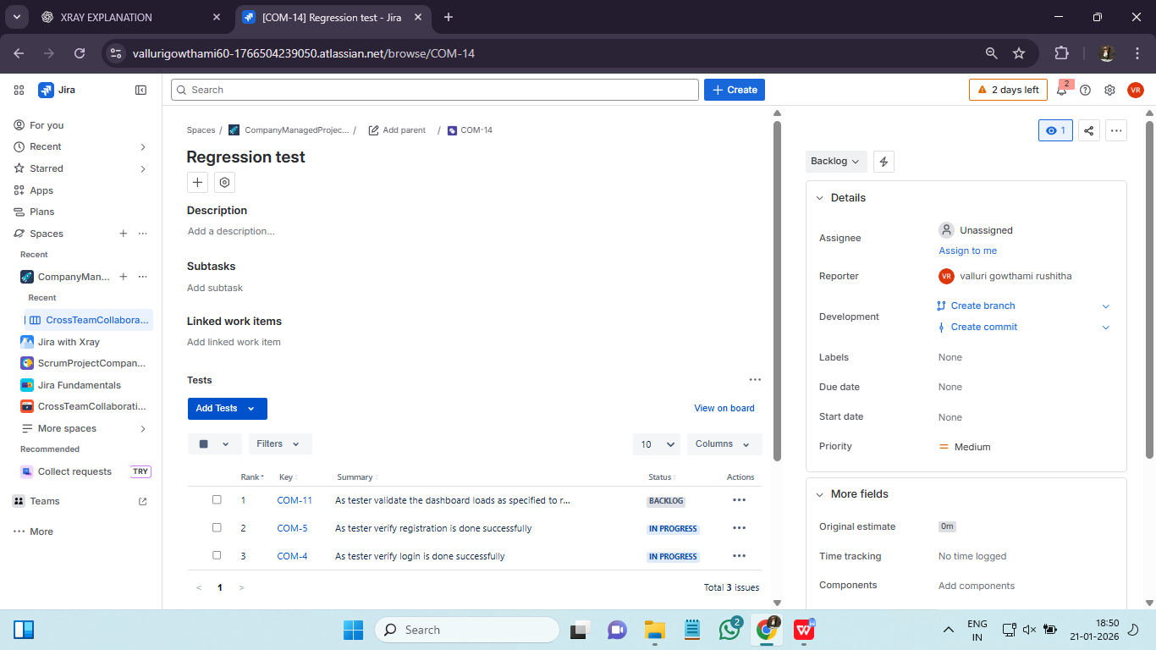
Reusable Test Packs :
Reusable test packs are collections of stable and high-value test cases.
Benefits:
- Reduces test design effort
- Ensures consistency
- Speeds up execution
Test Sets are commonly used to manage reusable test packs in Xray.
Smart Test Selection :
Smart test selection involves choosing the most relevant tests based on:
- Code changes
- Risk areas
- Past defect history
Xray’s traceability and reporting features help teams identify the right tests to execute.
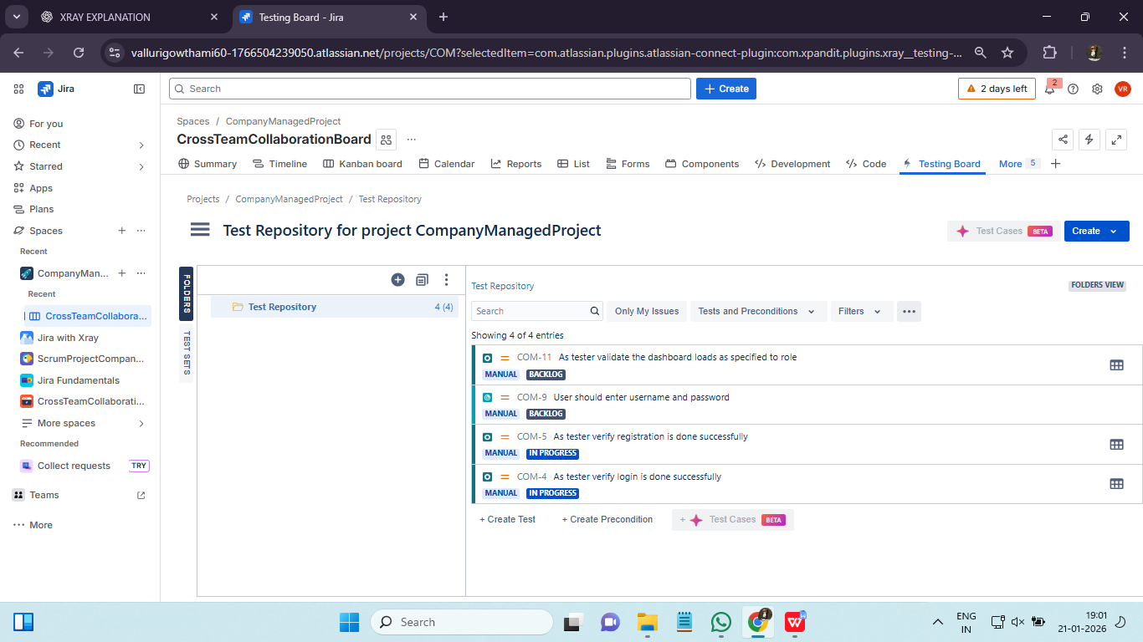

Traceability: Requirement → Test → Execution → Defect, coverage matrix, gap identification ::
Traceability connects requirements, tests, executions, and defects.
Traceability Flow:
Requirement → Test → Test Execution → Defect
This end-to-end traceability ensures transparency and accountability.
Coverage Matrix and Gap Identification :
Coverage matrices show which requirements are covered by tests and their execution status.
Benefits:
- Identify untested requirements
- Detect missing test cases
- Improve coverage quality
Gap analysis helps teams address risks early.

Compliance View: Audit readiness, reporting expectations, stakeholder visibility ::
In regulated industries, audit readiness is critical.
How Xray Supports Compliance:
- Maintains execution history
- Stores evidence and approvals
- Provides traceability reports
This makes Xray suitable for enterprise and compliance-driven projects.
Stakeholder Visibility :
Test planning data in Xray is accessible to:
- QA teams
- Developers
- Product owners
- Management
This shared visibility promotes collaboration and trust.

